Columns

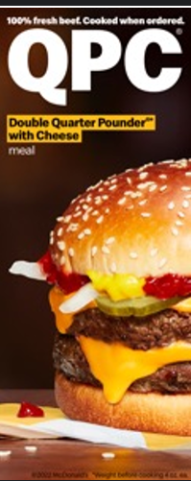  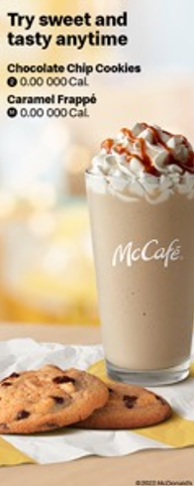 | Combo Meals  Meals include medium fries and medium soft drink, pick a different drink for an additional charge. Promotion pricing may be lower than meal pricing  1 Cheese 3.00 000-0000 Cal Ala carte 5.00 000 Cal Deluxe 3.00 000-0000 Cal Ala carte 5.00 000 Cal 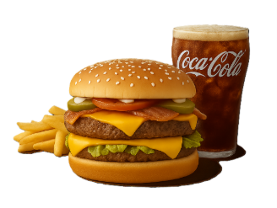  2 Quarter Pounder®tt Cheese 3.00 000-0000 Cal Ala carte 5.00 000 Cal Cheese & Bacon 3.00 000-0000 Cal Ala carte 5.00 000 Cal Deluxe 3.00 000-0000 Cal Ala carte 5.00 000 Cal 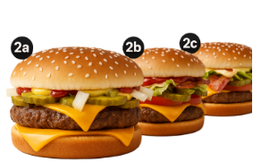  3 Double Quarter Pounder® with Cheese 3.00 000-0000 Cal Ala carte 5.00 000 Cal 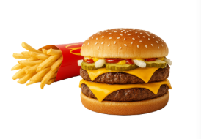  4 10 pc. Chicken McNuggets® 3.00 000-0000 Cal Ala carte 5.00 000 Cal 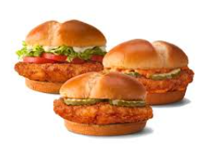  5 2 Cheeseburgers 3.00 000-0000 Cal Ala carte 5.00 000 Cal 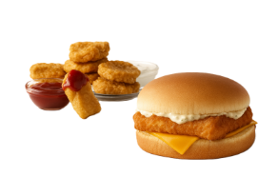 |  | $1 $2 $3 Dollar Menu  Value Beverages  Any Size Sweet Tea  S3.00 0-000 Cal  M3.00 0-000 Cal  L3.00 0-000 Cal  Soft Drinks  M3.00 0-000 Cal  Premium Roast Coffee  M3.00 0 Cal  Everyday Value  McChicken®  3.00 000 Cal  Double 4 pc. Chicken McNuggets®  3.00 000-0000 Cal  sauces add 30-000 Cal na  Basket of Fries  3.00 000 Cal  More Deals  4 Hot'n Spicy McChicken®, 20 pc. Chicken McNuggets®t & Basket of Fries  M3.00 000-0000 Cal

